**Simplilearn Phase One Project**

**LockedMe Application**

Core Concepts:

* The Core Concepts used in building the LockedMe Application are: Flow Control, Recursion, Exception Handling, File Handling, Sorting, Collections Framework, Streams API.

Approach for the LockedMe application

**Phase 1:** Create new project in Eclipse

* Open Eclipse.
* Go to File -> New -> Project -> Java Project.
* Type the project name and click on finish.
* Select your project and go to File -> New -> Class.
* Create class with WelcomeMain.java as class name

**Phase 2:** Code for welcome screen of the application

This is the entry point of the application containing the necessary methods to called for application functionality.

**Code:**

**package** com.lockedme;

**public** **class** WelcomeMain {

**public** **static** **void** main(String[] args) {

// Create "main" folder if not present in current folder structure

FileOptions.*mainFolderCreation*("main");

ApplicationMenu.*printWelcomeScreen*("LockedMe Application", "Badri Logaram");

HandlingFunctions.*handleWelcomeScreenInput*();

}

}

**Phase 3:** Code for Application Menu Items functionality

The Application Menu file consist of the Welcome Screen result and the menu options functionality.

The menu options consist of 3 functionalities as listed below:

1) Retrieve all files inside "main" folder

2) Display menu for File operations

3) Exit program

* The first option approach is done using sorting to list out all the files available in the directory
* The approach for second option is done using File Handling for necessary file options which will be described in next phase.
* The last approach for the final option to exit the application.

Application UI:

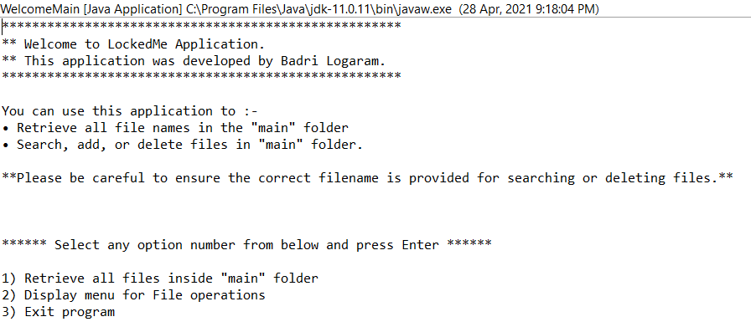

**Phase 4:** Code for Handling functions of the File Operations.

This phase consists of the functionality which is to be done on the File Operations.

The functionality is available as below:

* **First option is to retrieve the files in ascending order-** This approach is done using sorting.

Below available is UI for listing all the files available in ascending order.

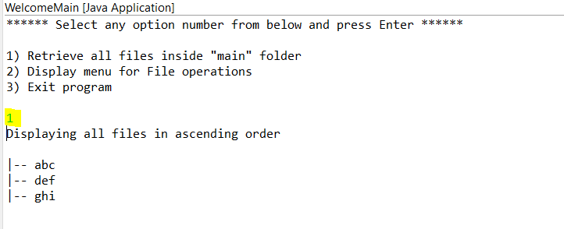

* **Second option is for the file operations-** This approach is done using File Handling as to Add, Delete, Search the file in the directory.

Below available is UI for listing the file options:

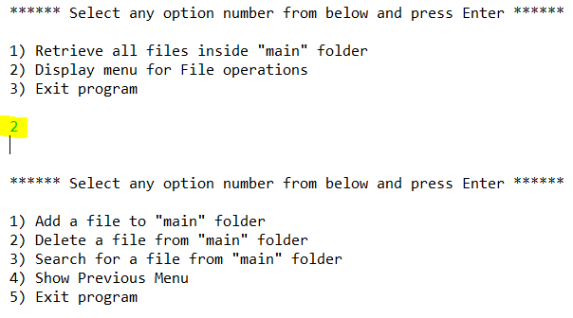

1. To add a file in main folder- Enter the name of the file and press Enter Key:

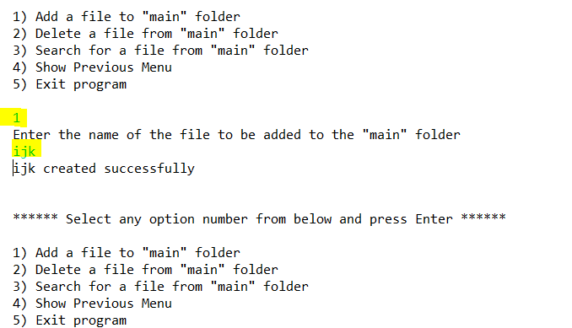

1. To delete a file in main folder- Enter the name of the file to be deleted and enter the index value and press Enter Key:

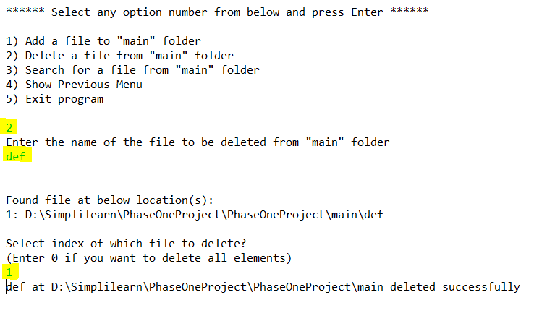

1. To search the file in main folder- Enter the name of the file to be searched in main folder: 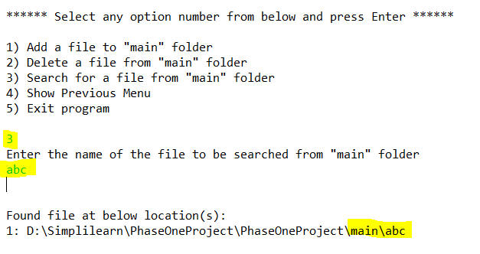

If the file is not present the application will indicate the message as “**Couldn't find any file with given file name”**.

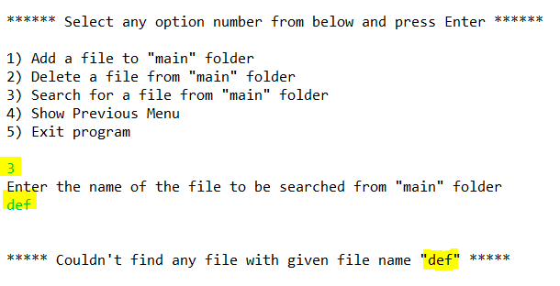

1. This option is to go back to the previous menu:

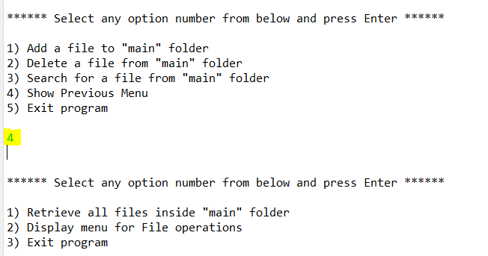

1. This option is to directly exit the application from the process:

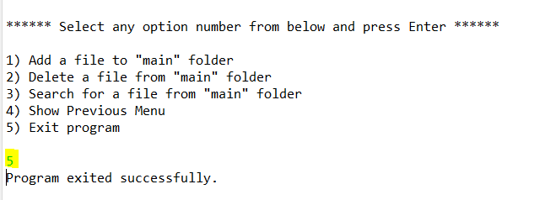

**Phase 4**: Code for all the File Operations background functionality.

The background operations consist with the following methods:

* **Creating “main” folder in project if it’s not already present**

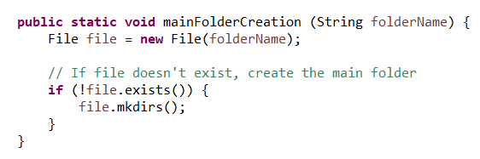

* **Displaying all files available in “main” folder in ascending order.**

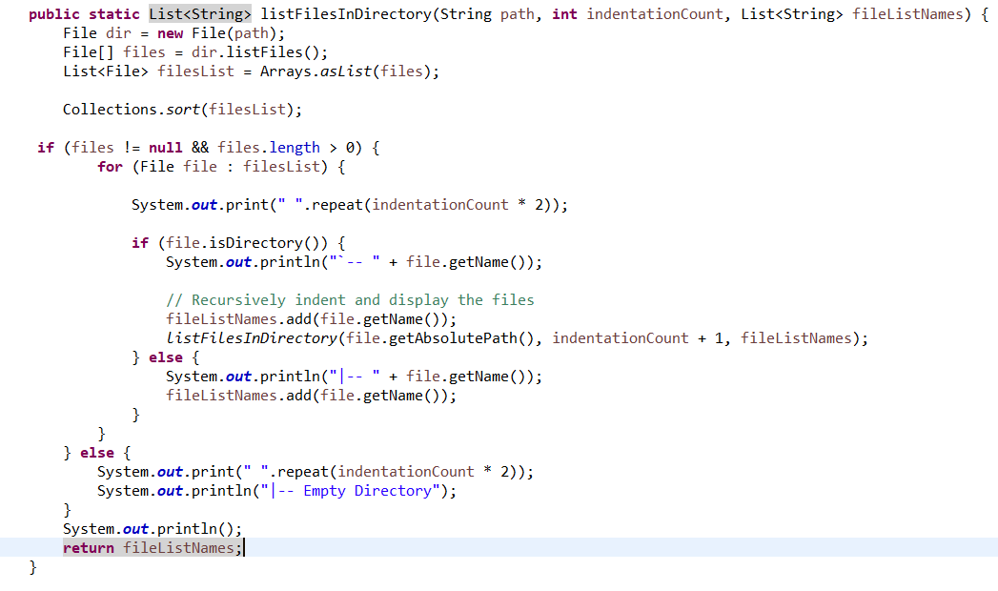

**Result:**



* **Creating a file as per the user requirement.**

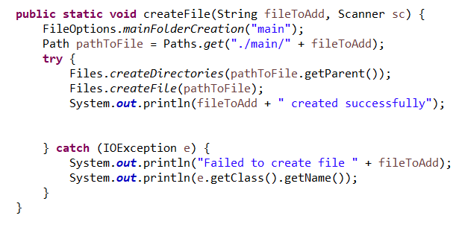

**Result**:



* **Search files in the “main” folder.**

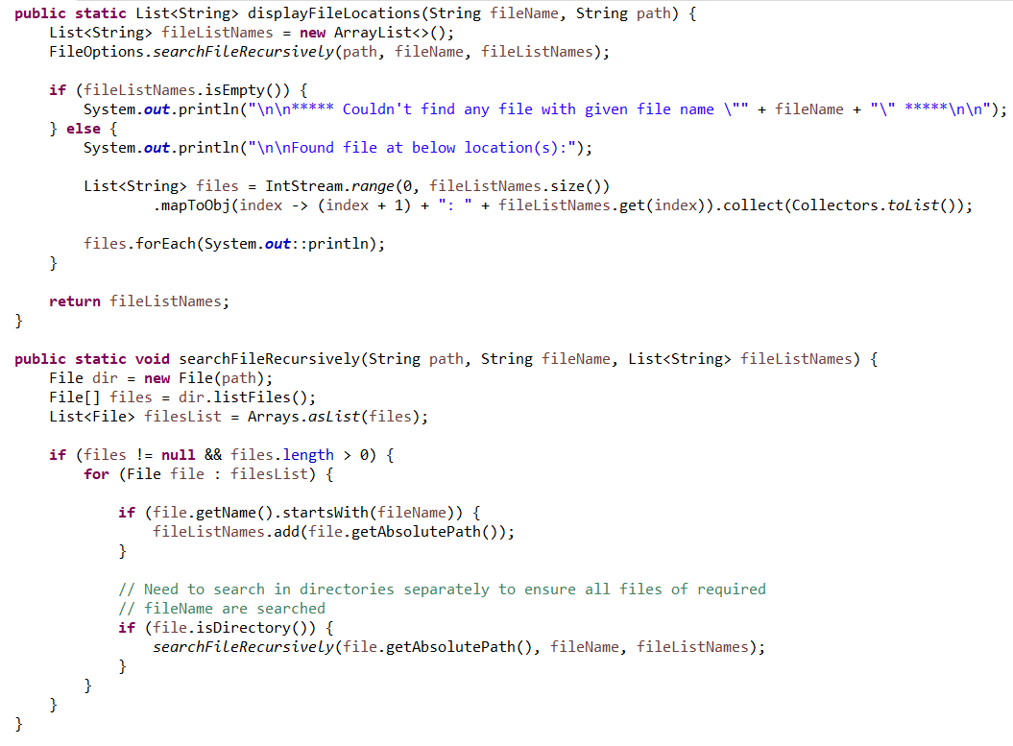

**Result:**



* Deleting a file from “main” folder.

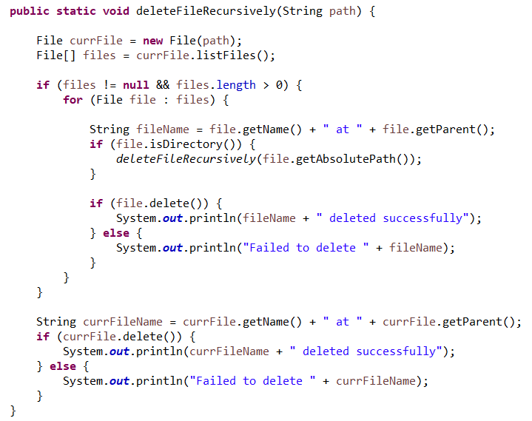

**Result:**



**Phase 5: Push the code to GitHub**

* Open command prompt on the path where the code repository has been created
* Initialized the git on the repository using command:

**git init**

* Added all the files to the repository using command:

**git add .**

* Committed the changes to git using command:

**git commit . -m “initial commit”**

* Pushed the code to GitHub using command:

**git push -u origin master**